Experiment #2 – MATLAB

# Youssef Samwel

# [yo800238@ucf.edu](mailto:yo800238@ucf.edu)

# EEE3352 Signal Analysis and Analog Communications

# Due Date 9/26/2023

# **Project Description**

# Introduce students to computer software, MATLAB. The students will learn syntax, vector and matrix operations, numerical approximation of linear and piece-wise functions, and data visualizations.

# **2.0 About Laboratory Day**

# The laboratory session took place on the Tuesday section between 9:00am and 11:50am on September 19, 2023. The lab was individual and did not require a partner to complete. The only required equipment for this lab was a personal computer.

# **3.0 Pre-laboratory Questions**

There were no pre-laboratory questions for this laboratory.

# **4.0 Experiment Procedure**

The goal of this laboratory is to expose students to MATLAB capabilities. The lab manual instructs the students to numerically evaluate three functions and plot said functions on a 2-dimensional plane using MATLAB’s plot function.

The functions to be evaluated are:

$$x_{1}\left(t\right)=t^{2}-2t+3 -10≤t≤10$$

$$x_{2}\left(t\right)=4\cos\left(2πt-\frac{π}{8}\right)+3\sin\left(2πt\right) -2≤t≤2$$

$$x_{3}\left(t\right)=sinc\left(t\right)=\frac{\sin\left(t\right)}{t}$$

$$x_{4}\left(t\right)=e^{-at}$$

# Part 1

In part 1, the lab manual instructed to plot the following functions:

1. $x_{1}\left(t\right)$ and $x_{2}\left(t\right)$.
$x_{3}\left(t\right);-2π≤t≤2π$

2. Plot $x_{4}\left(t\right)$ for $a=0.1,1,3$ on the range $0≤t≤10$ on one plot.

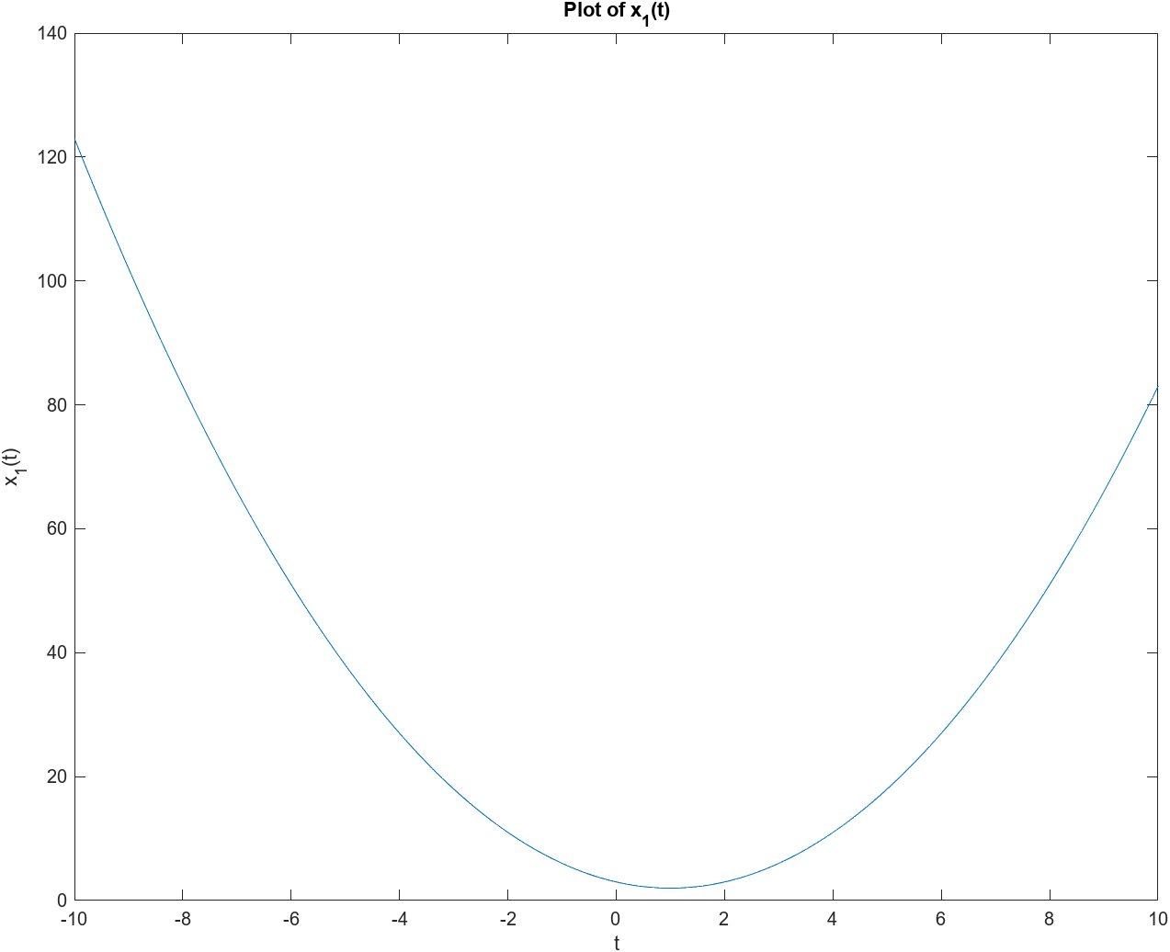

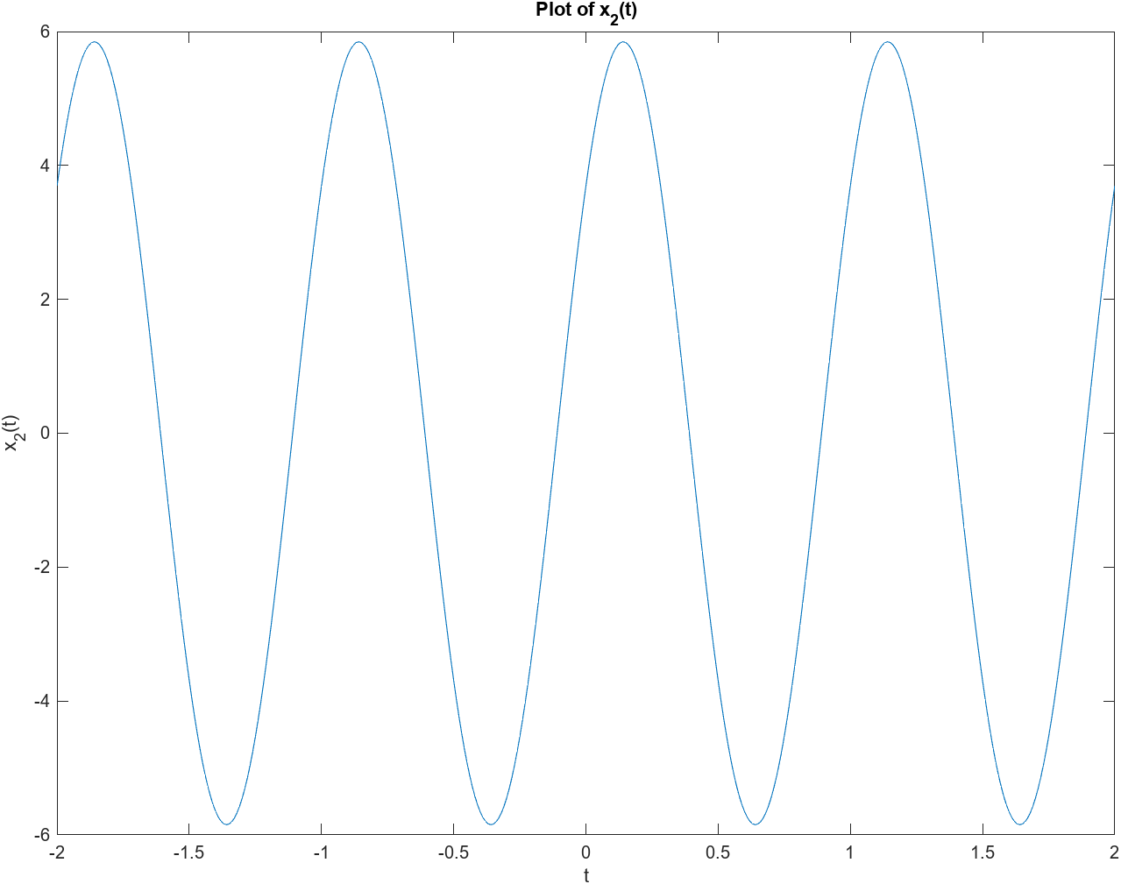

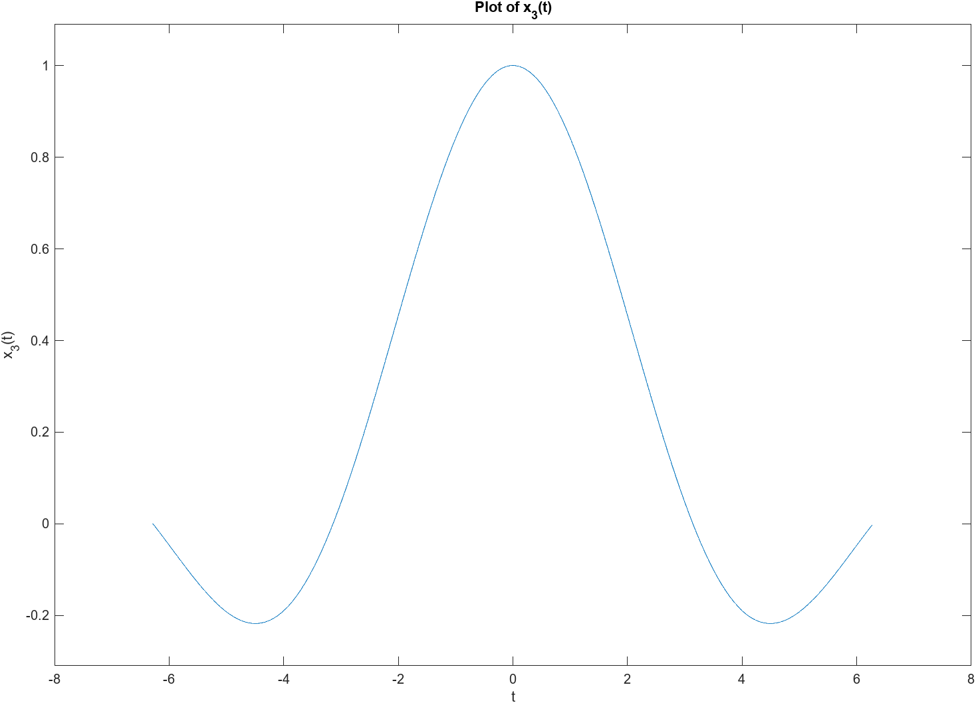

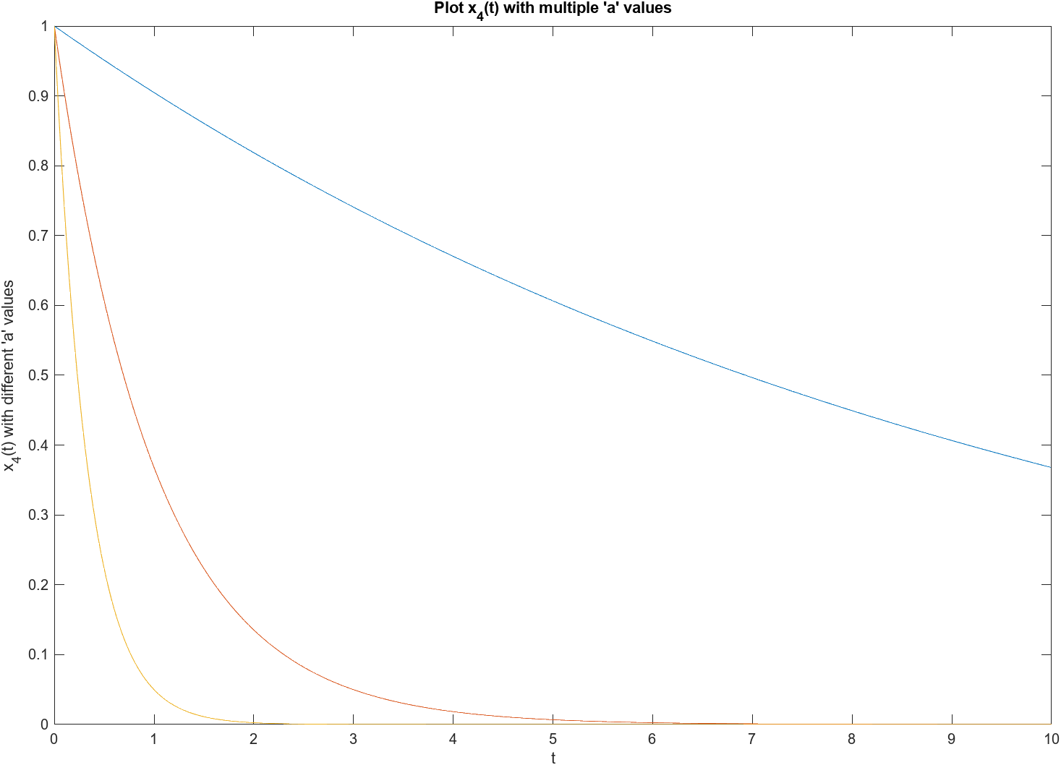

# Part 2

For Part 2, the lab manual instructed to replot the functions in Part 1 but using integer steps instead of rational steps.

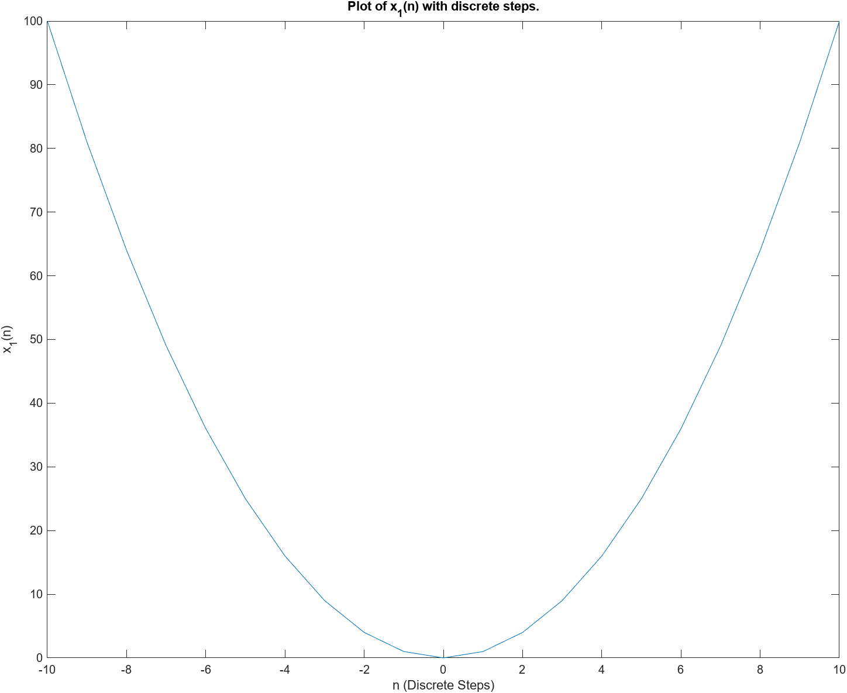

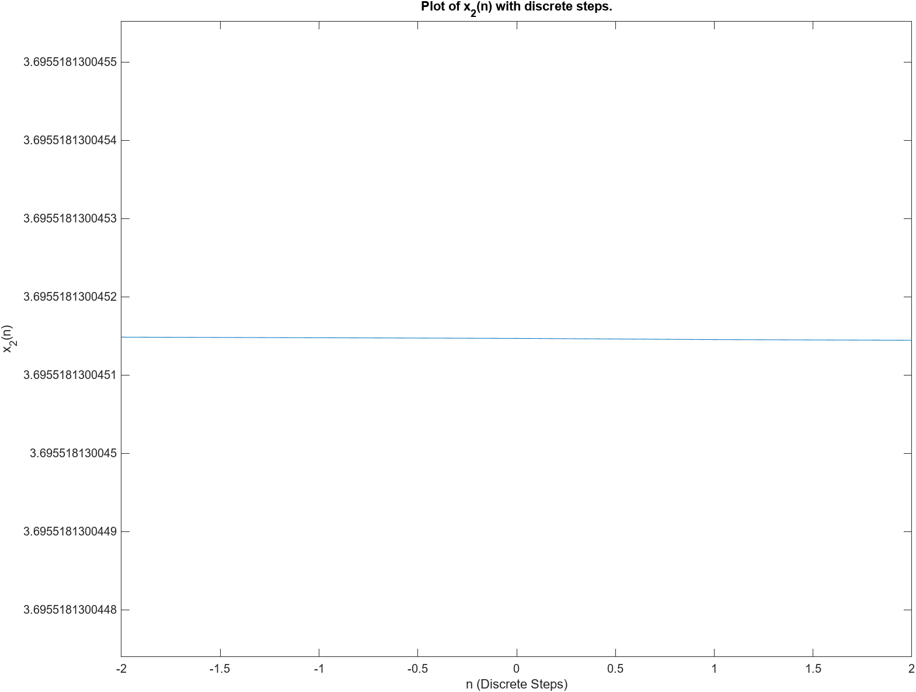

It is clear that the discrete versions of the plot contain much less data than their equivalent with rational steps. Specifically, for $x_{2}\left(t\right)$, the function is completely flat this is due the repetitive nature of sinc function and therefore the plot loses all detail compared to the rational version. For the other functions, some details could still be seen, however, the quality of the plots is much reduced.

# Part 3

For Part 3, we create a plot of a piece-wise function by using “for loop” and conditional statements and by using vector evaluations.

$$y\left(t\right)= \left\{\begin{aligned}\begin{aligned}x_{1}\left(t\right) \\ x_{2}(t)\end{aligned} \\ x_{3}(t)\end{aligned} | \begin{aligned}\begin{aligned}-4<t<-2 \\ -2<t<2\end{aligned} \\ 2<t<4\end{aligned}\right\}$$

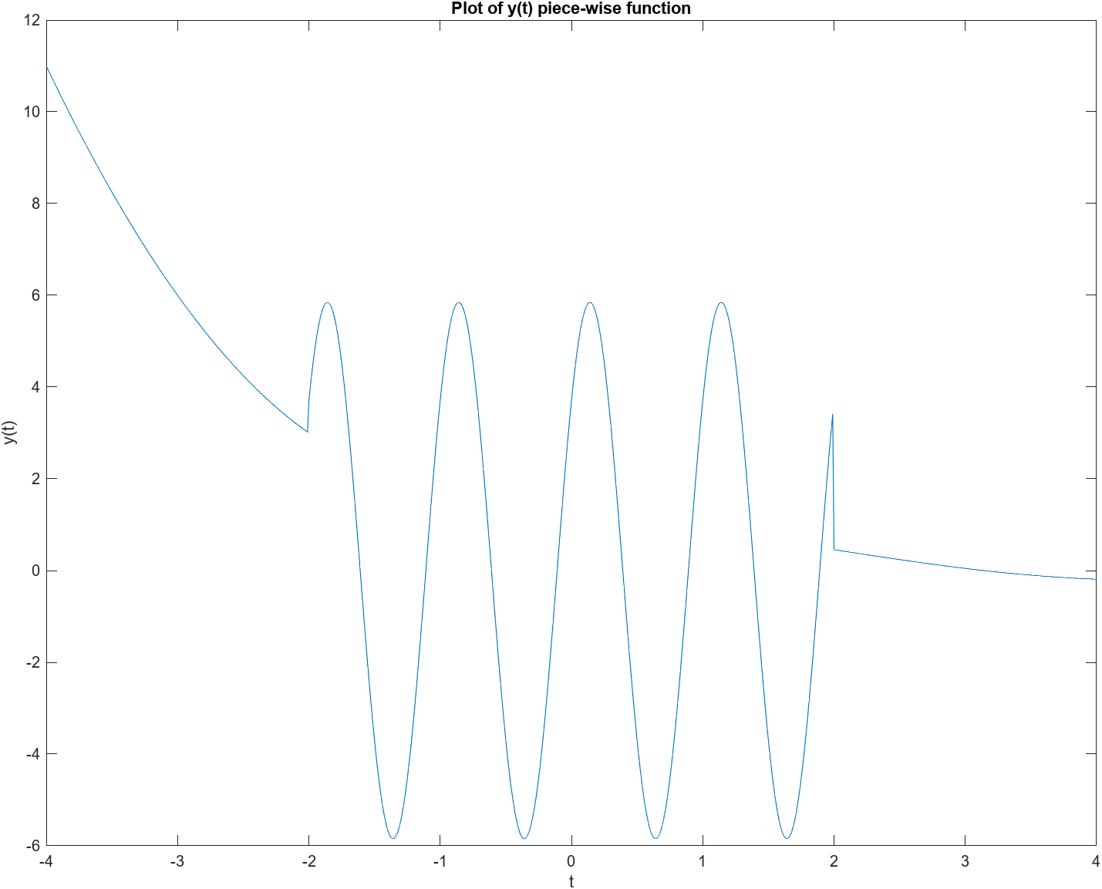

# **5.0 Experiment MATLAB Code**

# Part 1

%% problem 1

% x1(t)

t = -10:0.01:10;

x1 = n.^2; - 2.*t + 3;

plot(n, x1);

xlabel("t");

ylabel("x_1(n)");

title("Plot of x_1(t).");

% x2(t)

t = -2:0.01:2;

x2 = 4*cos(2*pi.*t - pi/8) + 3*sin(2*pi.*t);

plot(t, x2);

xlabel("t");

ylabel("x_2(t)");

title("Plot of x_2(t).");

% x3(t)

t = (-2*pi):0.01:(2*pi);

x3 = sin(t)./t;

plot(t, x3);

xlabel("t");

ylabel("x_3(t)");

title("Plot of x_3(t).");

% x4(t)

t = 0:0.01:10;

a = 0.1;

x4 = exp(-a.*t);

xlabel("t");

ylabel("x_4(t, a)");

plot(t, x4);

hold on;

a = 1;

x4 = exp(-a.*t);

plot(t, x4);

a = 3;

x4 = exp(-a.*t);

plot(t, x4);

title("Plot of x_4(t) w/ multiple values of 'a'.");

# Part 2

%% problem 2

% x1(n)

n = -10:1:10;

x1 = n.^2; - 2.*n + 3;

plot(n, x1);

xlabel("n (Discrete Steps)");

ylabel("x_1(n)");

title("Plot of x_1(n) with discrete steps.");

% x2(n)

n = -2:1:2;

x2 = 4*cos(2*pi.*n - pi/8) + 3*sin(2*pi.*n);

plot(n, x2);

xlabel("n (Discrete Steps)");

ylabel("x_2(n)");

title("Plot of x_2(n) with discrete steps.");

% x3(n)

n = (-2*pi):1:(2*pi);

x3 = sin(n)./n;

plot(n, x3);

xlabel("n (Discrete Steps)");

ylabel("x_3(n)");

title("Plot of x_3(n) with discrete steps.");

% x4(n)

n = 0:1:10;

a = 0.1;

x4 = exp(-a.*n);

xlabel("n (Discrete Steps)");

ylabel("x_4(n, a)");

plot(n, x4);

hold on;

a = 1;

x4 = exp(-a.*n);

plot(n, x4);

a = 3;

x4 = exp(-a.*n);

plot(n, x4);

title("Plot of x_4(n) w/ multiple values of 'a' and discrete steps.");

# Part 3

%% Problem 3

i = 1;

% pre allocate memory

y = -4:0.01:4;

for t=-4:0.01:4

    if t < -2

        y(i) = t^2 + 2*t + 3;

    elseif t < 2

        y(i) = 4*cos(2*pi*t - pi/8) + 3*sin(2*pi*t);

    else

        y(i) = sin(t)/t;

    end

    i = i + 1;

end

t=-4:0.01:4;

plot(t, y);

xlabel("t");

ylabel("y(t)");

title("Plot of y(t) piece-wise function");

% vector method

t1=-4:0.01:-2;

x1 = t1.^2 + 2.*t1 + 3;

t2=-2:0.01:2;

x2 = 4*cos(2*pi*t2 - pi/8) + 3*sin(2*pi.*t2);

t3=2:0.01:4;

x3 = sin(t3)./t3;

plot(t1, x1, t2, x2, t3, x3);

xlabel("t");

ylabel("y(t)");

title("Plot of y(t) piece-wise function");

**5.0 Learned Objectives**

* Visualization of Data
* MATLAB Vector and Matrices
* Numerical Analysis of Linear Functions
* MATLAB Scripting Language
* Control Flow in MATLAB
* Boolean Algebraic Expressions in MATLAB

# **6.0 Conclusion**

In this MATLAB lab, we learned to use MATLAB for data visualization and analysis. We plotted various functions and understood the impact of step size on plots. We also created a piece-wise function using conditional statements and vectors. These activities helped us achieve our learning objectives in MATLAB usage for signal analysis and analog communications.